**National Institute of Technology, Warangal**

**End Lab Exam – MCA 5th Sem**



***Software Testing***

**Name – Divyanshu Shrivastava**

**Roll No. – 187909**

**MCA 3rd Year**

**Reg. No. – MC18111**

**Task 2 – Salenium IDE**

**Definition –**

Selenium is an umbrella project for a range of tools and libraries that enable and support the automation of web browsers.

It provides extensions to emulate user interaction with browsers, a distribution server for scaling browser allocation, and the infrastructure for implementations of the W3C WebDriver specification that lets you write interchangeable code for all major web browsers.

This project is made possible by volunteer contributors who have put in thousands of hours of their own time, and made the source code freely available for anyone to use, enjoy, and improve.

**Different platfform offer by Selenium?**

## WebDriver

If you are beginning with desktop website or mobile website test automation, then you are going to be using WebDriver APIs. [*WebDriver*](https://www.selenium.dev/documentation/en/webdriver/) uses browser automation APIs provided by browser vendors to control browser and run tests. This is as if a real user is operating the browser. Since WebDriver does not require its API to be compiled with application code, it is not intrusive.

## IDE

[*IDE*](https://selenium.dev/selenium-ide) (Integrated Development Environment) is the tool you use to develop your Selenium test cases. It’s an easy-to-use Chrome and Firefox extension and is generally the most efficient way to develop test cases. It records the users’ actions in the browser for you, using existing Selenium commands, with parameters defined by the context of that element. This is not only a time-saver but also an excellent way of learning Selenium script syntax.

## Grid

Selenium Grid allows you to run test cases in different machines across different platforms. The control of triggering the test cases is on the local end, and when the test cases are triggered, they are automatically executed by the remote end.

After the development of the WebDriver tests, you may face the need of running your tests on multiple browser and operating system combinations. This is where [*Grid*](https://www.selenium.dev/documentation/en/grid/) comes into the picture.

***Performing Selenium Automation on https://www.leetcode.com***

1. Setting up Project

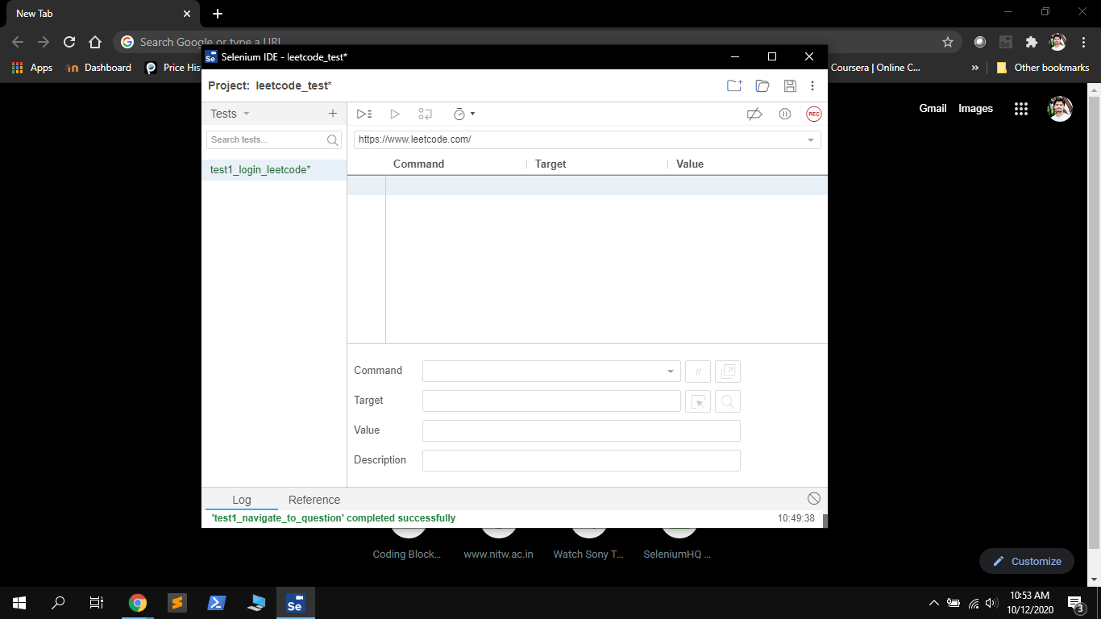

Creating Project

1. **Recording Test1 – Leetcode Login.**

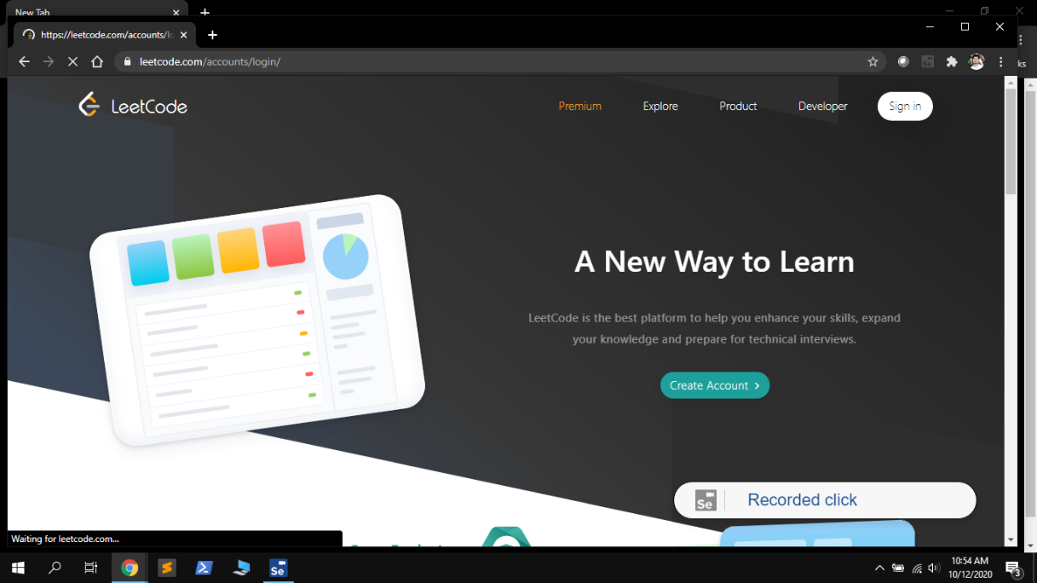

Recording Leetcode Loging by clicking sign in tab

1. **Recording Test1 – Leetcode Login**

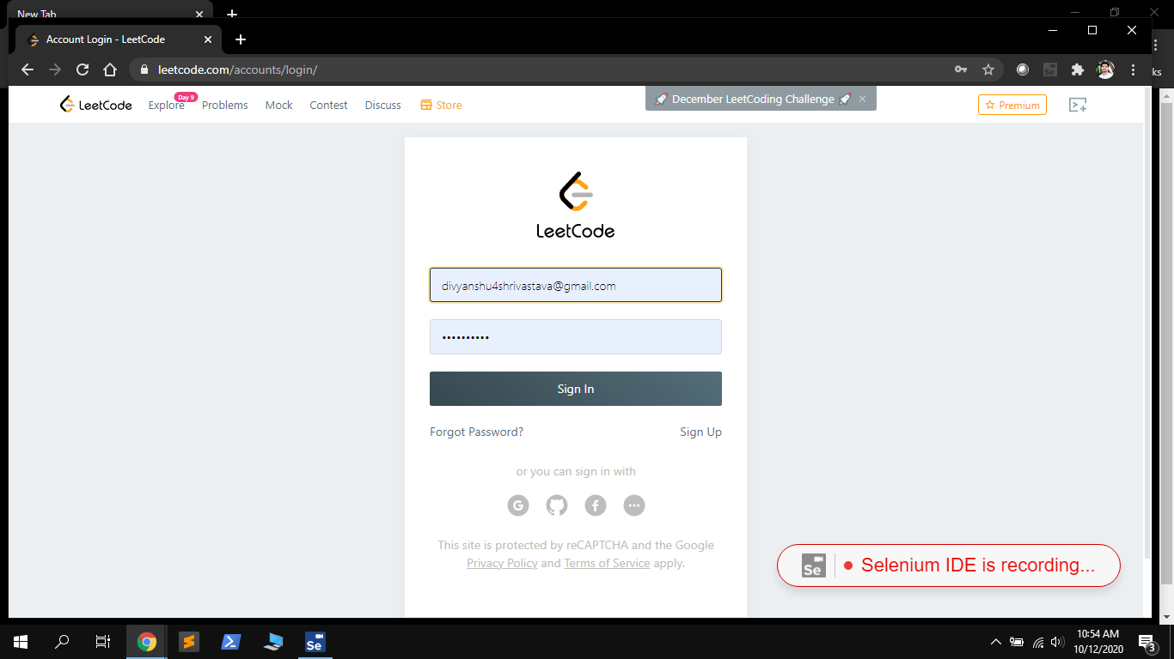

Entering login details on login page

1. **Executing Test1 – Leetcode Login**

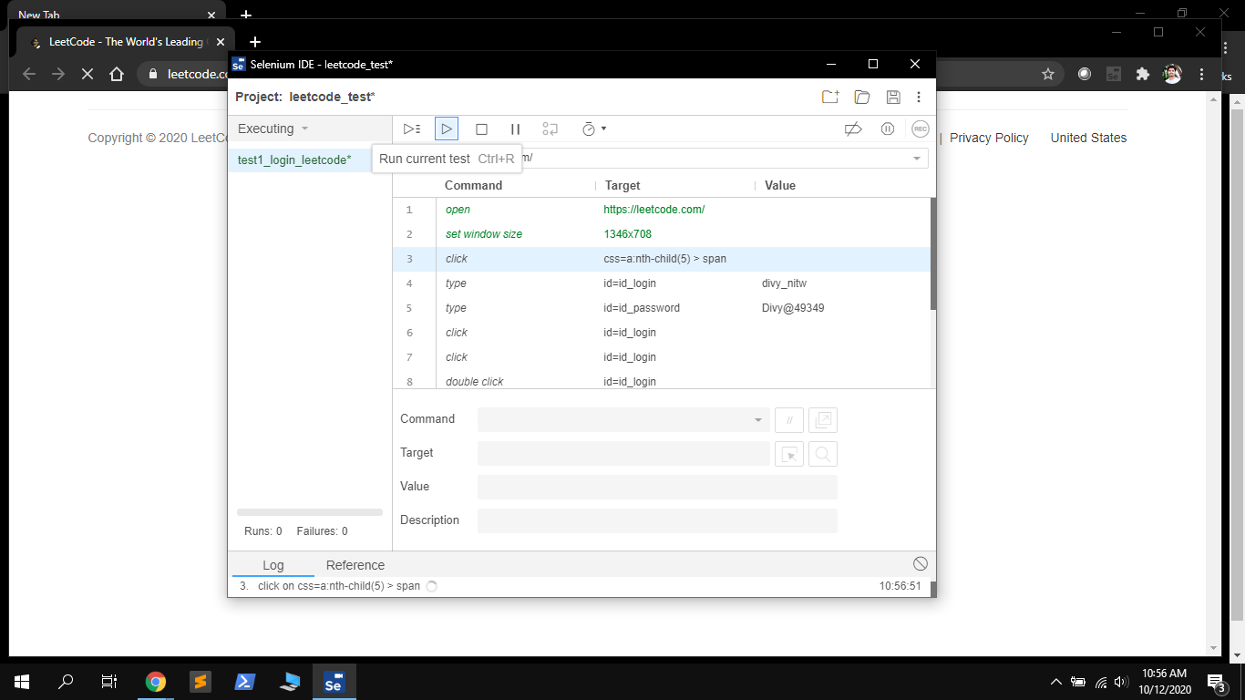

Executing the Login Task

1. **Executing Test1 – Leetcode Login**

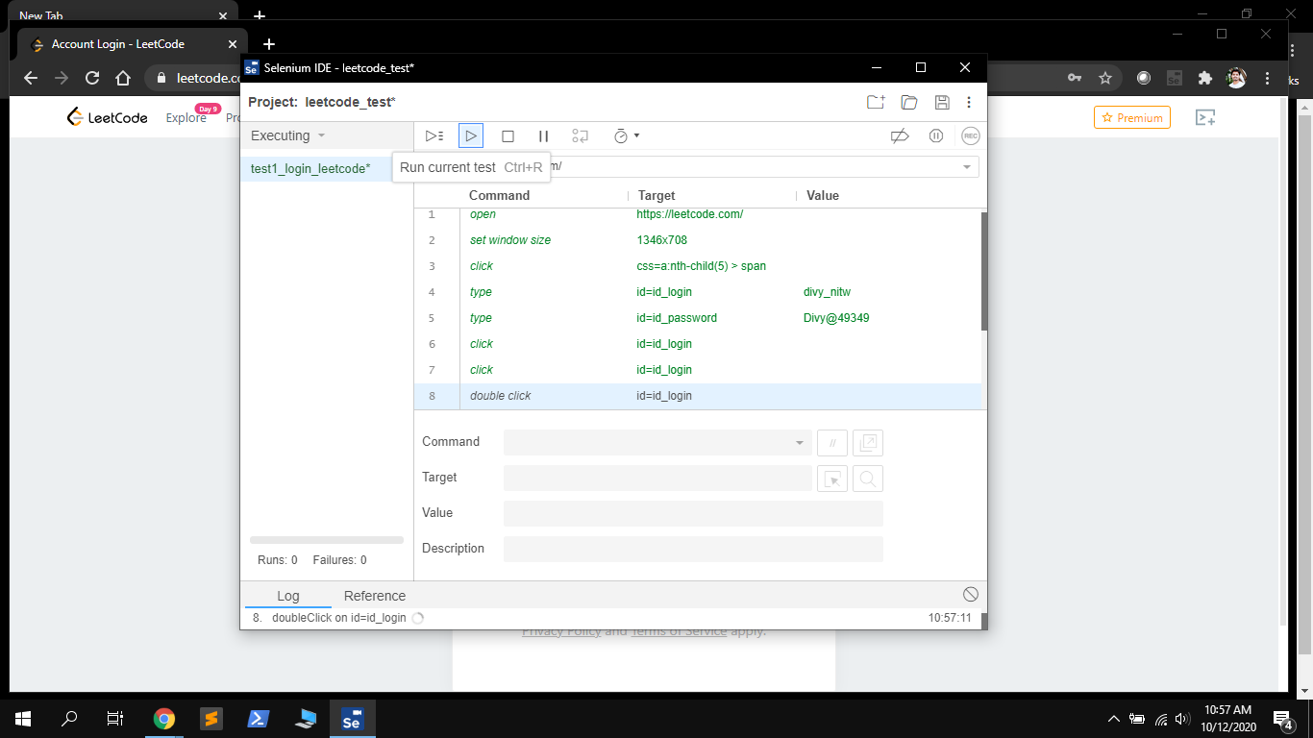

Steps included in login Task

1. **Executing Test1 – Leetcode Login**

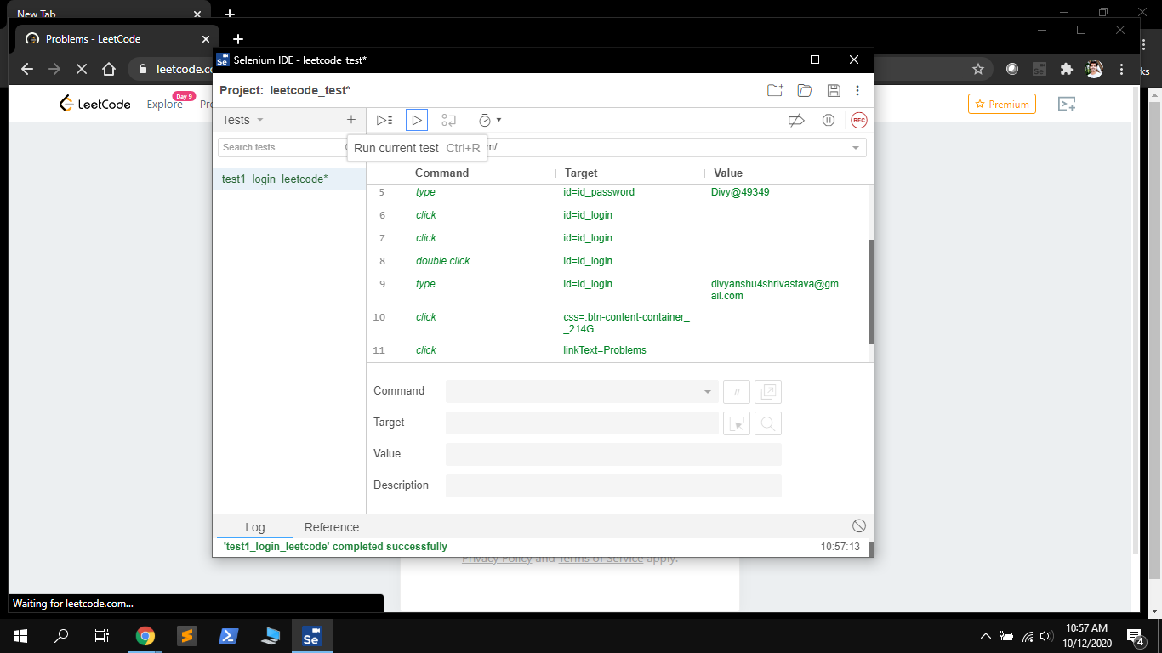

Login Leetcode task completed succesfully

1. **Recording Test2 – Solving a problem on Leetcode**

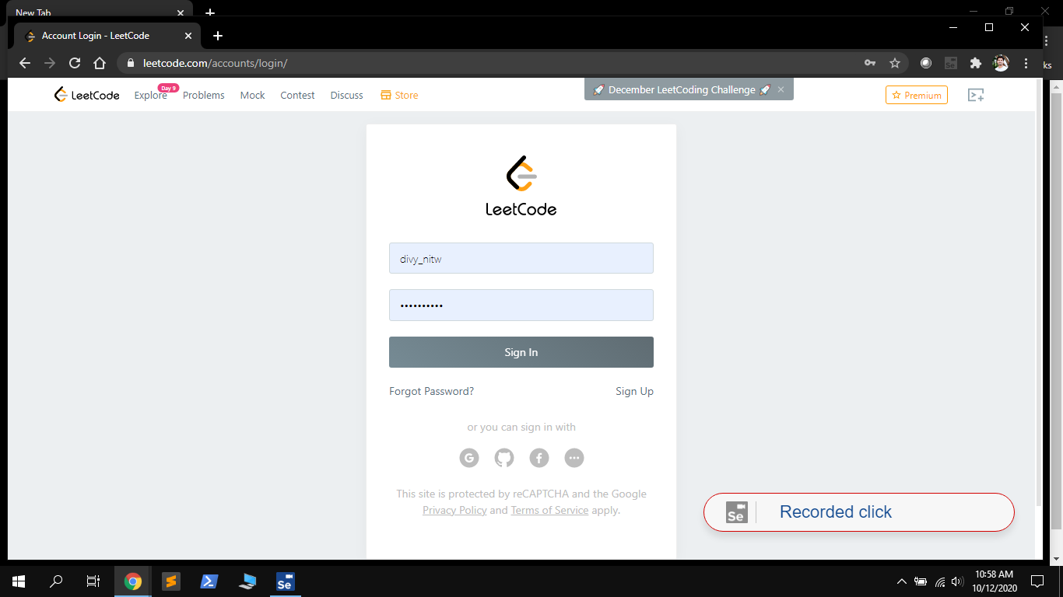

Recording login for solving a problem on leetcode

1. **Recording Test2 – Solving a problem on Leetcode**

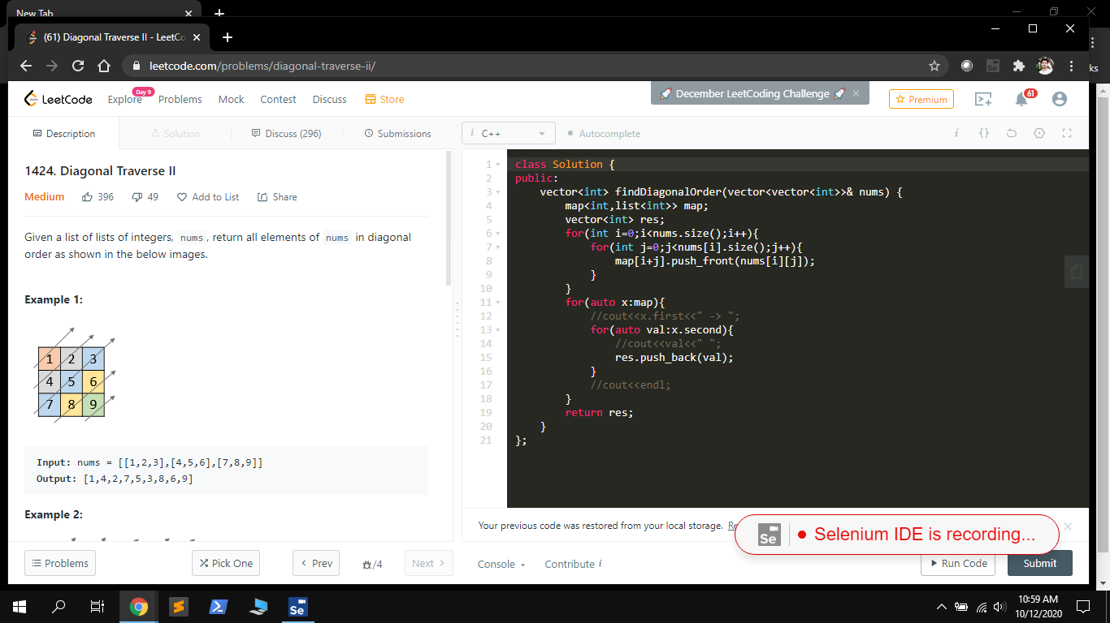

Navigate to the problem page

1. **Recording Test2 – Solving a problem on Leetcode**

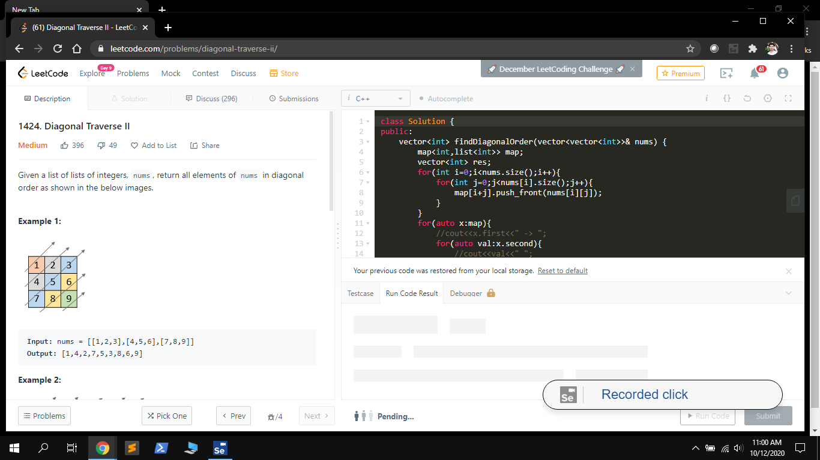

Cliking submit button for task submission and validation of testcases.

1. **Recording Test2 – Solving a problem on Leetcode**

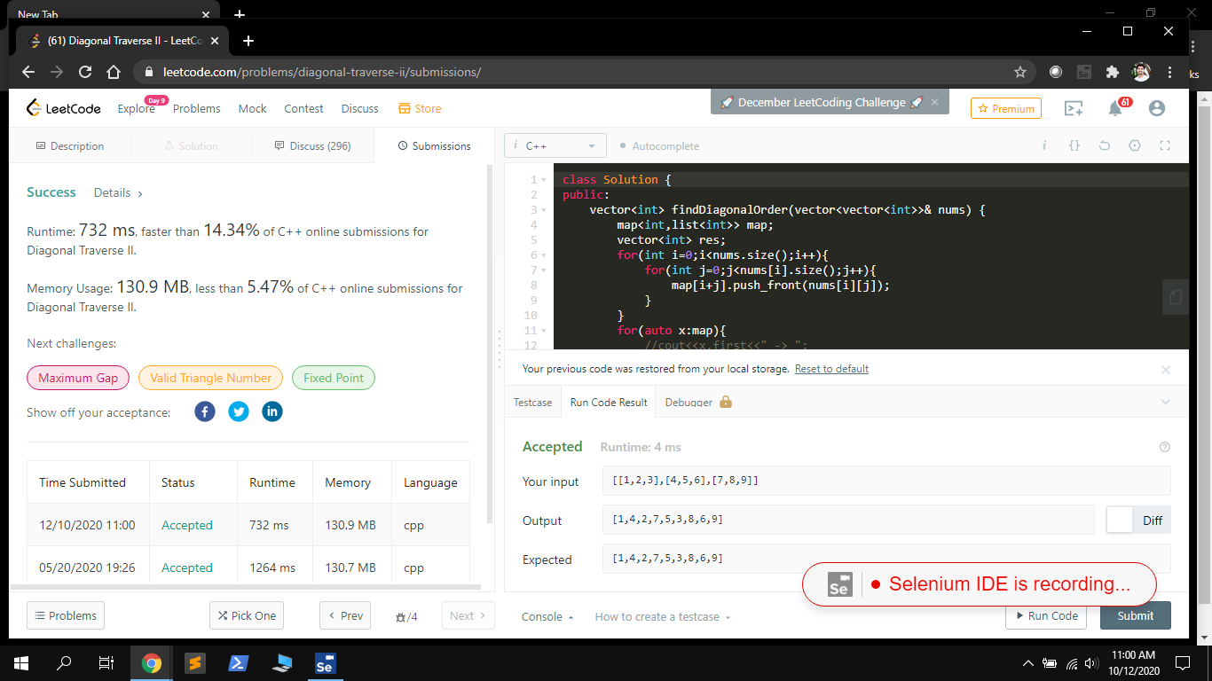

Correctness of the question is validated

1. **Executing Test2 – Solving a problem on Leetcode**

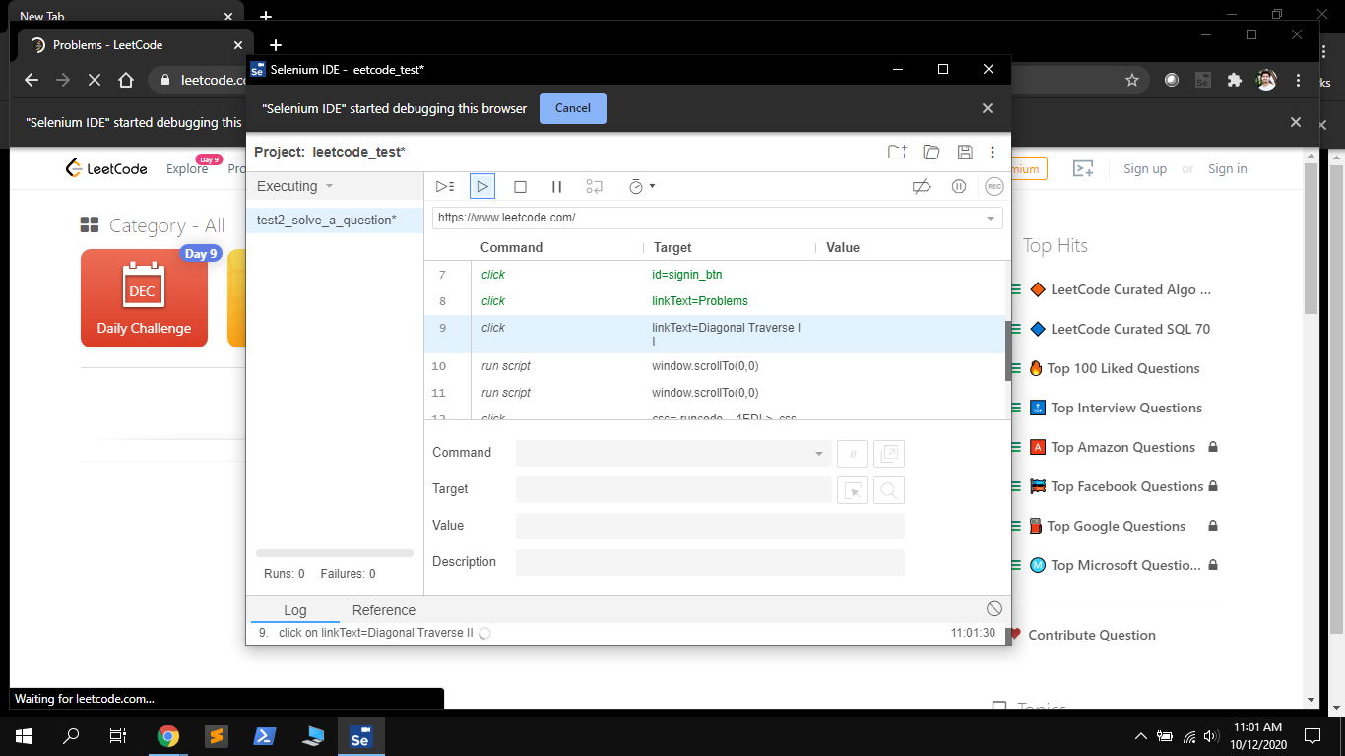

Executing the solve problem on leetcode

1. **Executing Test2 – Solving a problem on Leetcode**

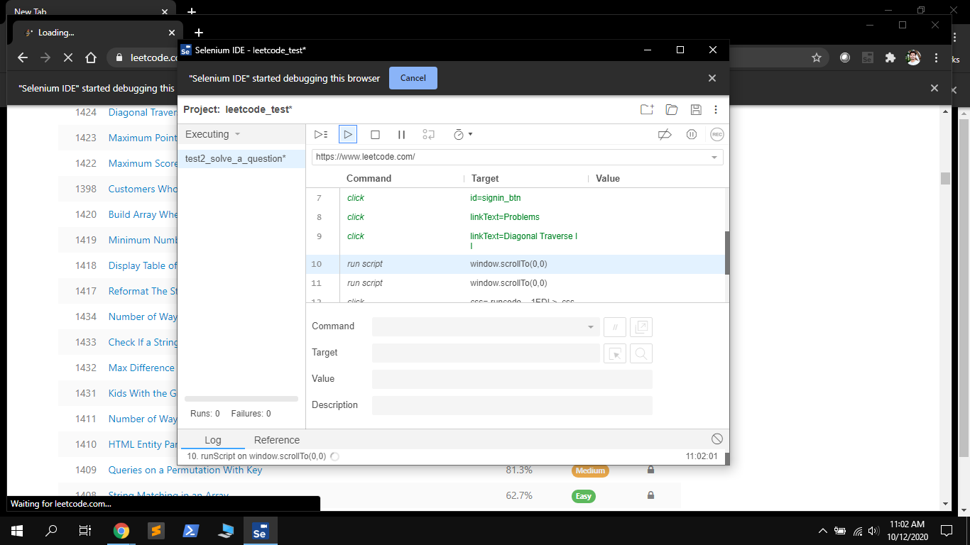

Navigating through the problems page and selecting question

1. **Executing Test2 – Solving a problem on Leetcode**

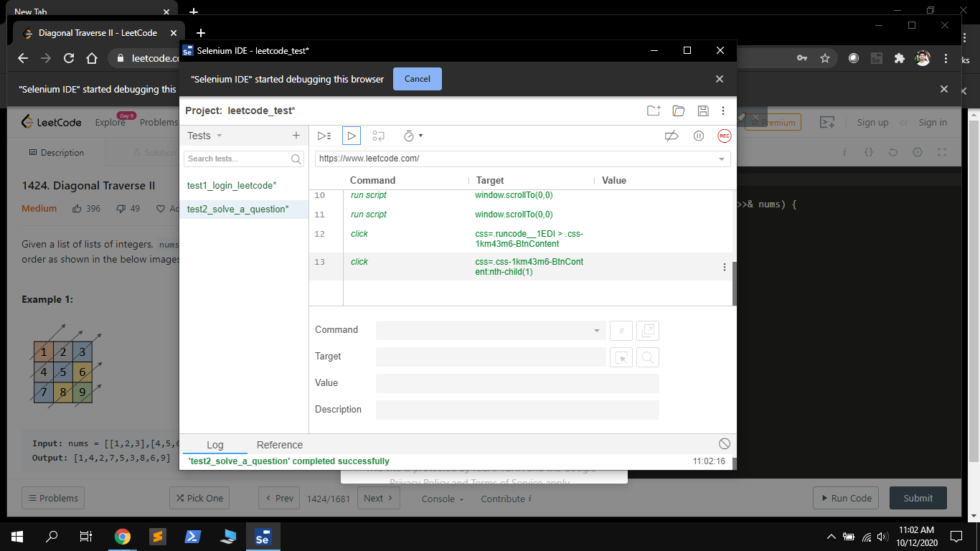

Progress of the task up to open the question

1. **Recording Test 3 – Show Leetcode Profile**

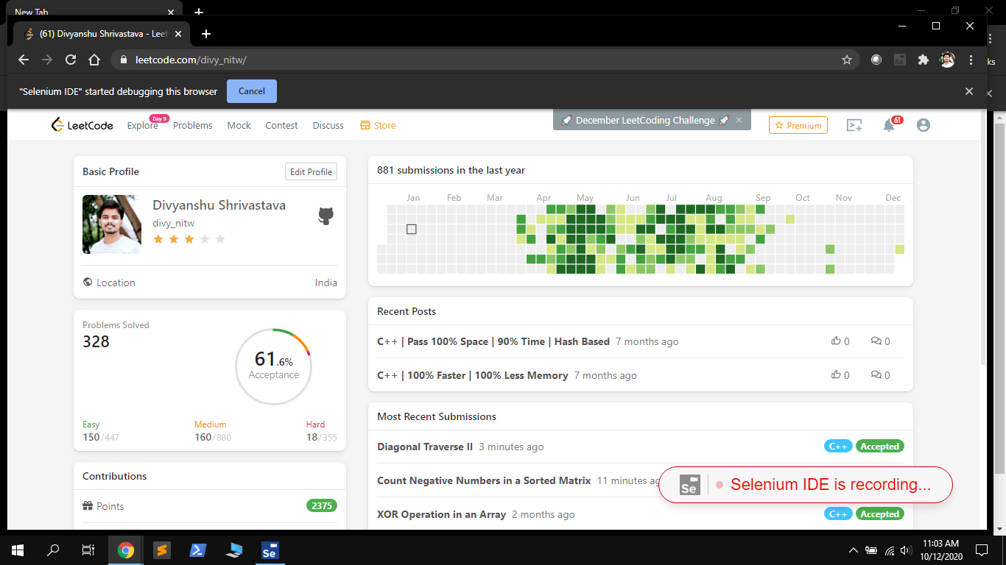

Recording leetcode to show profile

1. **Executing Test 3 – Show Leetcode Profile**

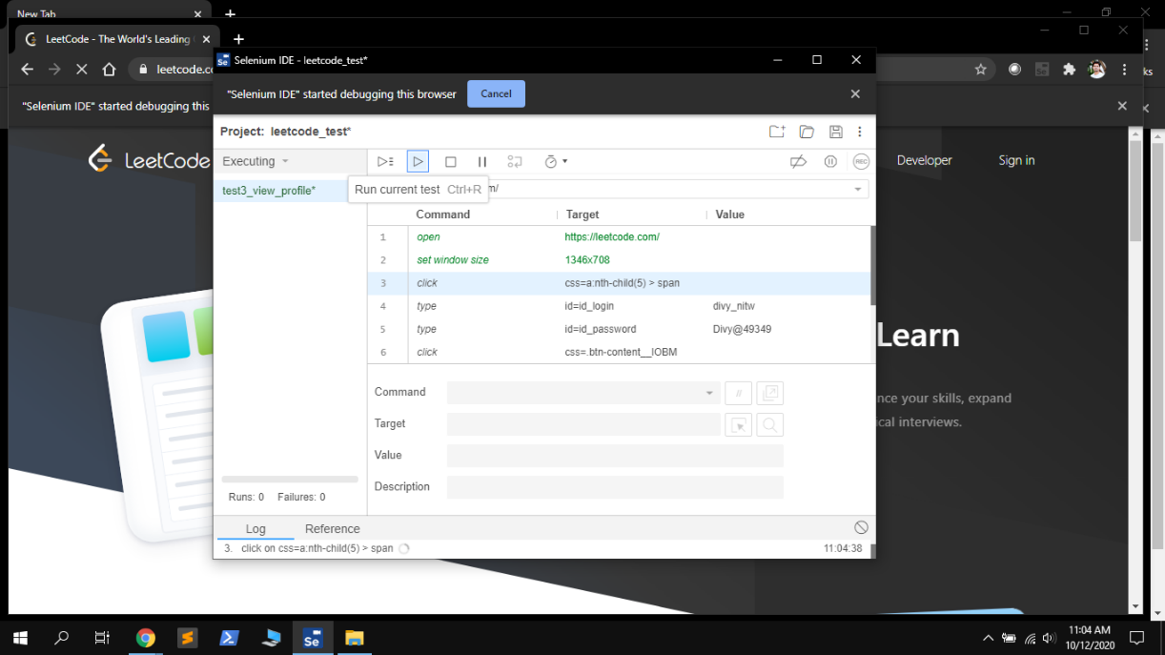

Executing leetcode view profile

1. **Executing Test 3 – Show Leetcode Profile**

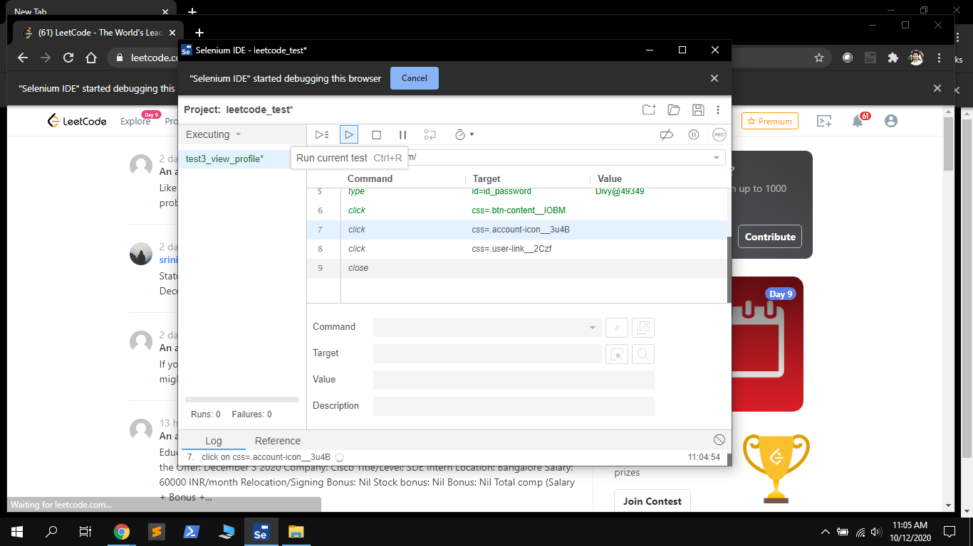

Selenium Performing task for leetcode view profile task

1. **Executing Test 3 – Show Leetcode Profile**

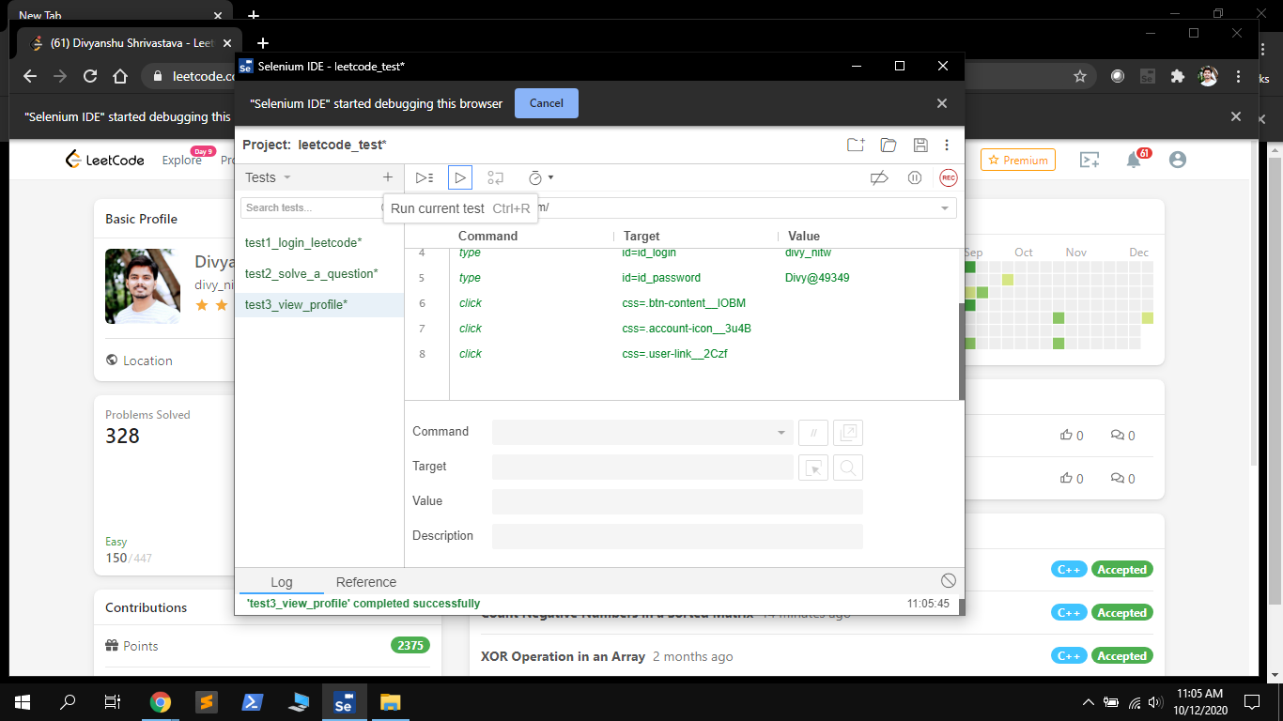

Task completed Successfully

***Performing Selenium Automation on https://www.google.com***

1. **Recording Test 1 – Google Search**

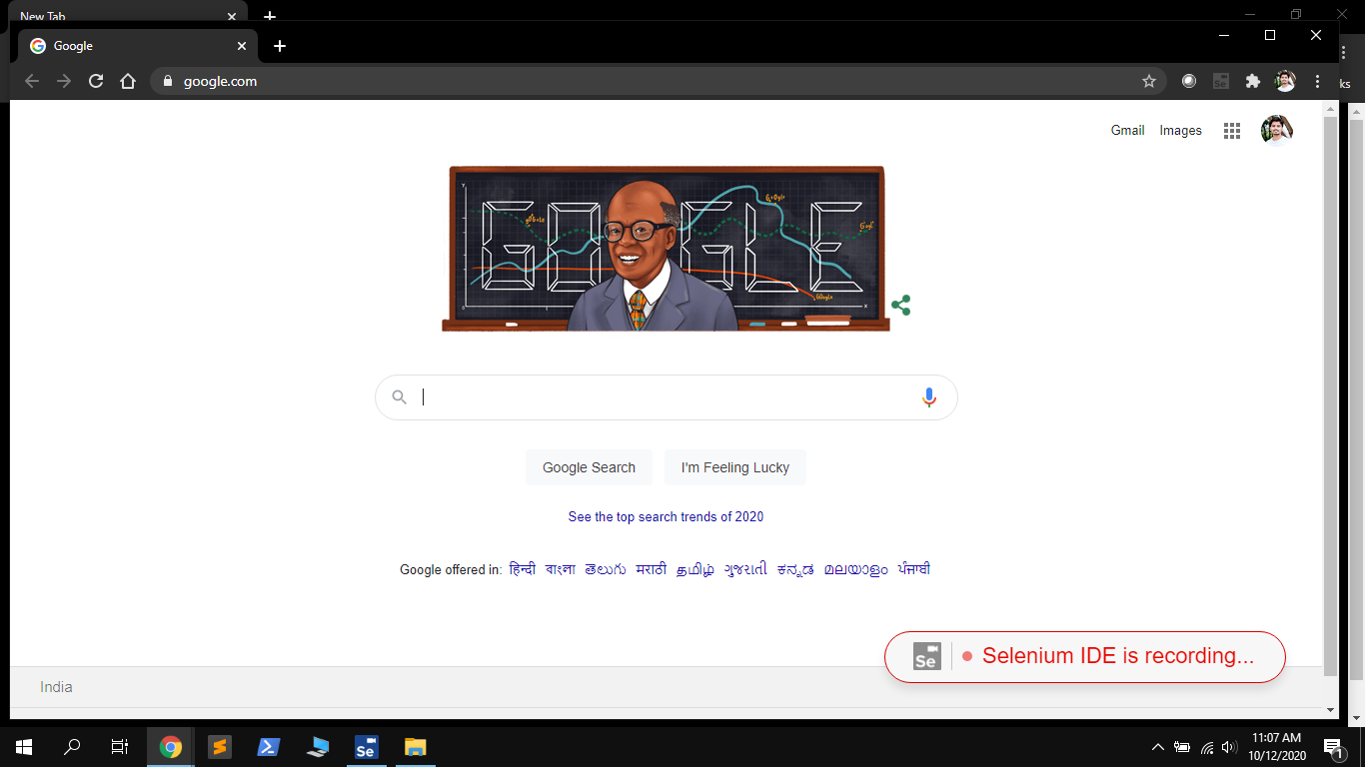

Recording google search

1. **Executing Test 1 – Google Search**

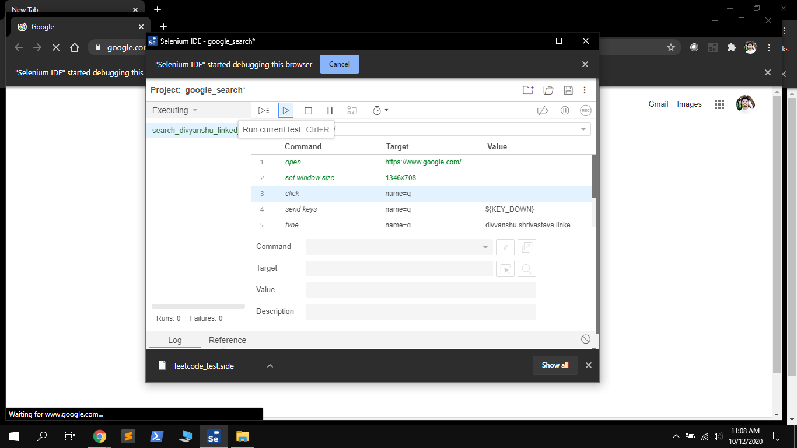

Selenium executing with recorded task

1. **Executing Test 1 – Google Search**

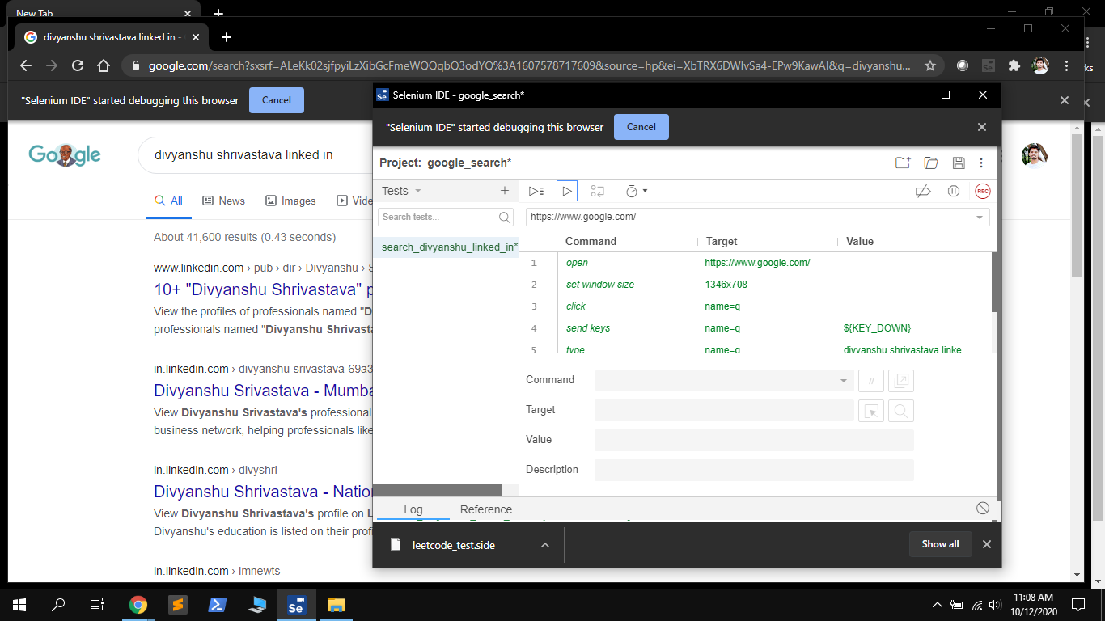

Execution completed with selenium searching google with our name.